**CSF 2113 Lab 3.2 Iterations (while loops)**

1. **Using while loop in python**
2. What is the output of following code segment?

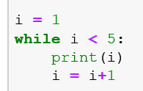

|  |
| --- |
| 1  2  3  4 |

1. What is the output of following code segment?

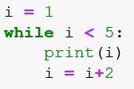

|  |
| --- |
| 1  3 |

1. What is the output of following code segment?

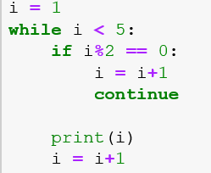

|  |
| --- |
| 1  3 |

1. What is the output of following code segment?

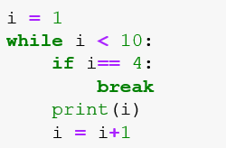

|  |
| --- |
| 1  2  3 |

1. **while loop statement in Python**
2. Write a program (using while loop) which take a range from the users and display all numbers in the range.

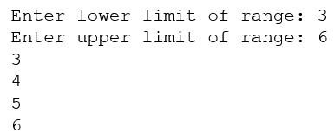

|  |
| --- |
| I = int(input(“Enter lower limit of range:”))  U= int(input(“Enter upper limit of range:”))  s=1  While s<=U:  Print(s)  s= s+1 |

1. Write a program (using while loop) which take a range from the users and display all odd numbers in the range.

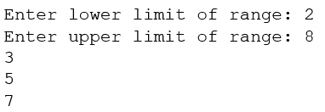

|  |
| --- |
| I = int(input(“Enter lower limit of range:”))  U= int(input(“Enter upper limit of range:”))  s=1  While s<=U:  If s%2!=0:  Print(s)  s= s+1 |

1. Write a program (using while loop) which take a range from the users and display all numbers which are multiple of 5 in the given range.

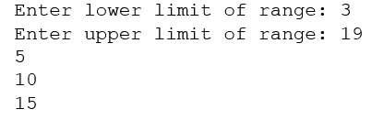

|  |
| --- |
| I = int(input(“Enter lower limit of range:”))  U= int(input(“Enter upper limit of range:”))  s=1  While s<=U:  If s%5= =0:  Print(s)  s= s+1 |

1. Write a program (using while loop) which take a range from the users and display sum of the numbers in the given range?

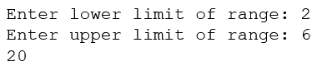

|  |
| --- |
| I = int(input(“Enter lower limit of range:”))  U= int(input(“Enter upper limit of range:”))  s=1  t=0  While s<=U:  t=t+s  s=s+1  Print(t) |

1. Write a program (using while loop) which take a range from the users and display sum of the all numbers which are multiple of 5 in the given range?

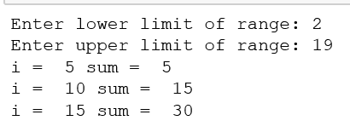

|  |
| --- |
| I = int(input(“Enter lower limit of range:”))  U= int(input(“Enter upper limit of range:”))  s=1  t=0  While s<=U:  s=s+1  if s%5 ==0:  t=t+s  Print(“i=” , s,”sum=”,t) |

1. Write a program (using while loop) which generate integer random numbers between 0 and 10. Program should display the generated numbers and it should terminate when zero is generated as random number?

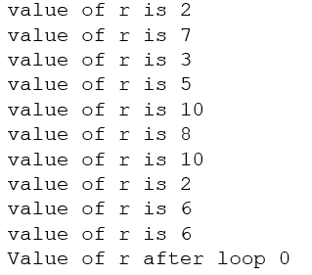

|  |
| --- |
| Import random  While True:  i= random.randint(0,11)  if i ==0:  print(“value of i after loop 0”)  break  else:  print(“value of i is”,i ) |

1. Write a program (using while loop) which takes a sequence of numbers from users. Program should stop taking input once user enter zero as input. Program should display the sum of all the numbers entered by user.

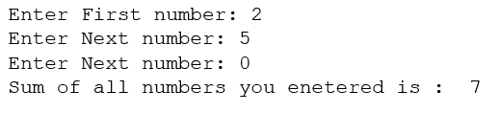

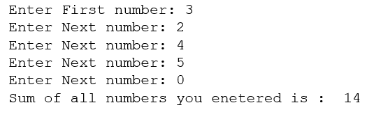

|  |
| --- |
| i=0  t=0  While True:  i=int(input(“”))  If i==0:  Print(“sum of all input is:”,t)  Break  else:  t=t+i |

**End of Lab**